**Bayesian Network**

Question 1)

1. Draw the Bayesian Network that corresponds to this conditional probability: P(D/A,B) P(E/D) P(B/A) P(C/A) P(C)

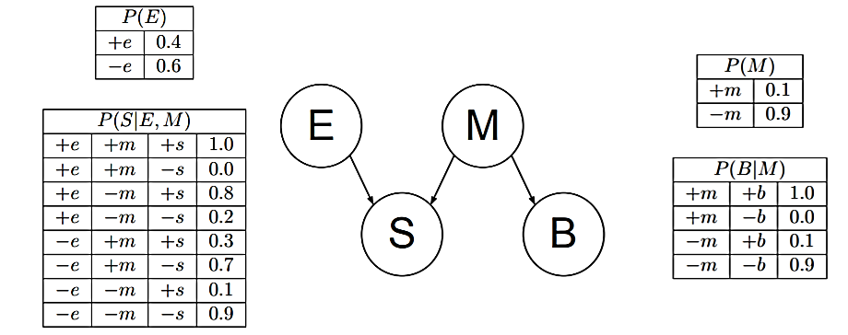

1b: Compute joint Distribution P (E, ¬M, S, ¬B, )?

2b: Calculate P(+M| + S, +B, +E) using the network given above.